📘 Lesson Plan: Algebraic Linear Relationships Using Ohm’s Law

🎯 Learning Objectives
By the end of this lesson, students will be able to:
- Use real-world data (from Ohm’s Law) to graph a line and determine the relationship between current and voltage
- Connect algebraic concepts to practical applications through modeling and analysis.

🧩 Materials Needed
- Desmos Online Graphing Calculator

🔍 Guided Practice: Algebra Meets Physics

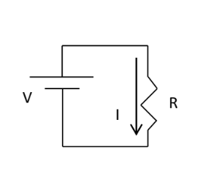
Suppose you conducted a lab with the simple circuit shown in Figure 1. Plot the points from the table using Desmos to determine the mathematical relationship between voltage and current.
Voltage (V) | Current (A)
0.65 | 0.12
1.41 | 0.29
2.55 | 0.51
3.28 | 0.67
4.11 | 0.81
6.15 | 1.23

Using Desmos to Plot Your Data:
Step 1 - Go to https://www.desmos.com/calculator and make sure to click on Tools >> Graphing Calculator
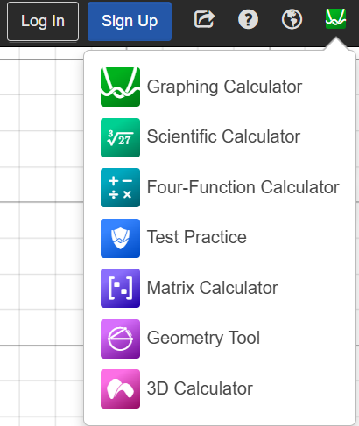

Step 2 - Let Voltage (V) be your x-variable and Current (A) be your y-variable. Plug in your points using the (x,y) format into the graphing calculator
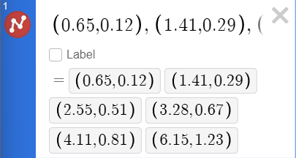

Step 3- Click and hover over the red circle to access add ons such as “labeling” and ”line”
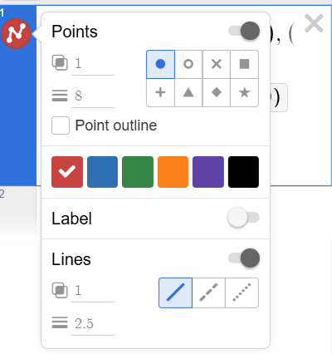

Step 4- Draw a line through your points and determine the relationship.
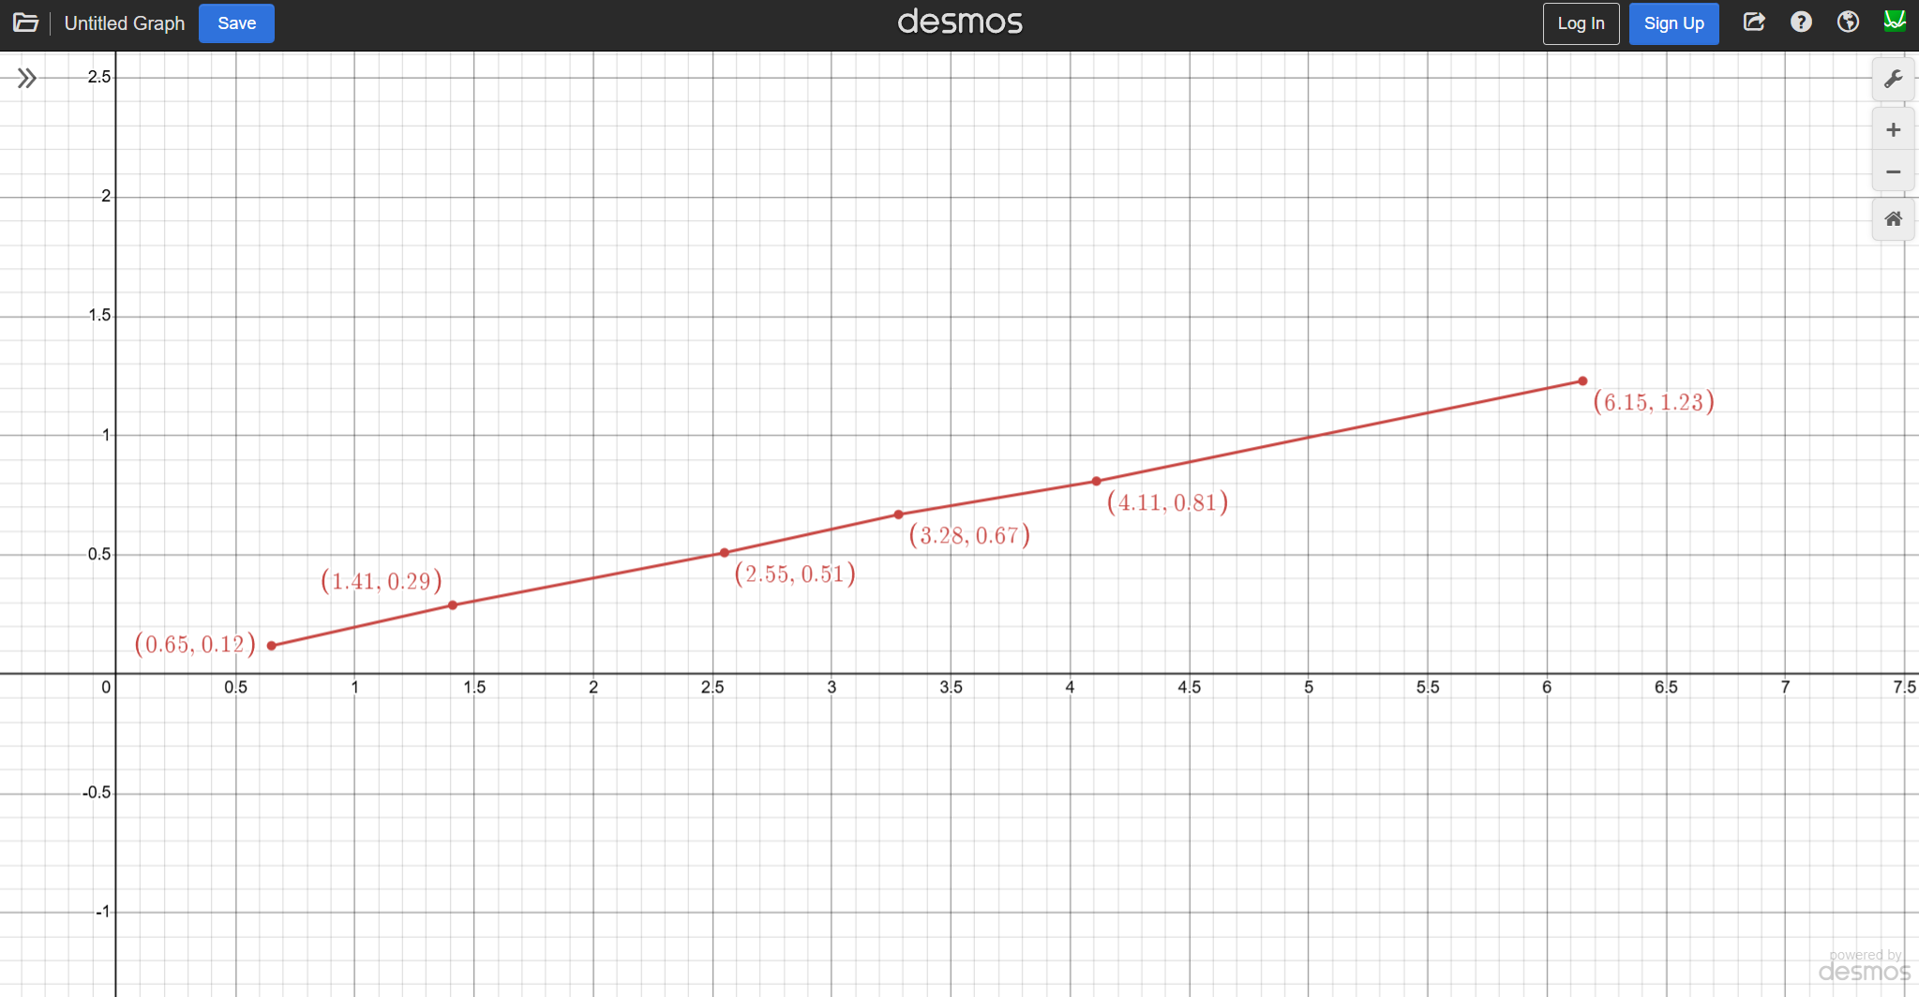

Reflection: Relationship Between Voltage and Current

Based on what you see, is the slope increasing or decreasing?

With this observation, when the voltage across the resistor increases, the current through it
______________.

